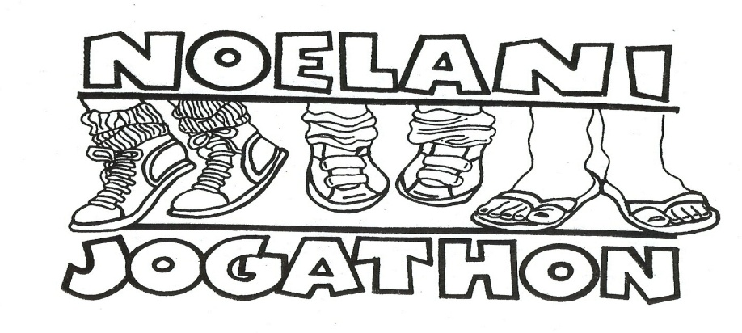
Friday,
Feb 7, 2019

8:30 to 10:30 a.m.

Our fun filled Jogathon 2020 is nearing!
This exciting event helps students get a jumpstart towards a healthy lifestyle, through physical fitness, as well as raises funds to support enrichment programs at Noelani.

What is Jogathon?
- The second largest fundraiser of the school year staged by our Noelani PTA.
- Students are sponsored by family and friends to jog or walk along a course that winds through the Noelani campus. The course is designed by our P.E. teacher, Mrs. Veronica Lum, and manned by parent-volunteers.

When is Jogathon?
- Friday, Feb. 7, 2019 from 8:30 to 10:30 a.m.
- Come! Parents, grandparents, relatives, friends! Cheer! Jog along! Walk along! Either way, we promise you a fun Friday morning with your children!!

What’s the educational purpose of Jogathon?
- To help students appreciate the importance of an active and healthy lifestyle.
- To provide an engaging school-wide learning experience for our students and to enhance their sense of place within the Noelani Ohana.

Where does Jogathon money go?

Thank you to everyone who made Jog-A-Thon 2019 a success!

The monies raised through this fundraising are used for fulfill the needs of our students and teachers!!
In the past the funds were used to support the following:

- The New Playground (2019)!
- The Cafeteria TV screens (2017)
- All students Chrome Books (2016)
- Automated external defibrillator –AED (2014)
- The PE and music programs, including teachers’ salaries, after-school activities, such as robotics, gardening, keyboarding, etc. (continued support)

This year our funds we’ll be used to 1) upgrade playground, 2) update all Chrome Books, 3) replace/repair cafeteria stage curtains

This year, let’s all work together to meet a goal of $38,000!
Exciting prizes will be awarded to sponsors!

Donations

Due Thursday, Feb. 6

  - Collect Donations
-- In cash or checks payable to “Noelani PTA” (Donation Collection envelope will be distributed in January)
-- Via Paypal: visit www.NoelaniPTA.org website, and click on the “Donate Now” red button
or go directly to: https://bit.ly/2SenjWE

  - Record Information -- Record each donor’s name and sponsorship amount and your contact email address on PayPal (under “Add special instructions to the seller”), or on the front of the Sponsorship Envelope –this is especially important if your sponsors need a TAX acknowledgment letter. If you used Paypal, please return the donation envelope with records of your sponsor’s names and paypal donation payment info.
  - Return Donation -- Return your donations and envelope to your classroom by: Thursday, Feb. 6, 2020.

Incentive Program:
The incentive program is designed to encourage our Noelani Ohana to come together to reach our goal of $38,000 in sponsorships (in order to achieve our goal, we are asking that each student will raise donations of at least $70).

Compared to the tuition of a private school, this is nothing, however this small amount of money means much to our school and can do lot for enriching the student experience at Noelani Elementary!

Prizes:
- Jogathon T-shirts. All students will receive a free Jogathon t-shirt regardless of the donation amount. T-shirts will be distributed to the classrooms a few days before Jogathon day (please encourage your joggers to wear it on Jogathon day).

- Student donations of $70 or more will receive a Noelani-printed memorabilia (details to follow).

- Donations of $100 or more and the 1st top fundraisers in each Homeroom will receive all above, plus extra amazing prizes (details to follow), and recognition as a “Platinum Club” member by posting the child name on the cafeteria bulletin board and on the Noelani PTA online pages. Moreover, their name will be entered into a drawing to win 2 major prizes and 1 grand prize (at least $100 value each).

Would your company like to donate to help enhance the Manoa community?
Corporate donations are more than welcome!

The Noelani School PTA is a non-profit, 501(c)(3) organization. Donors may deduct contributions as provided in IRC 170 of the U.S. Tax Code

Sponsorship Donations are voluntary. Noelani PTA is grateful for any level of support that can be provided and is very appreciative of donation in excess of target level!
Follow our fundraising progress on our Noelani PTA website and Facebook page for updates about the prizes.

Volunteer Sign Up!

Due Monday, Jan. 8

We Need YOU!

The success of Jogathon depends on the participation of our dedicated Noelani parents – our Noelani Ohana!

Please turn in your volunteer form or sign up on-line at

www.SignUpGenius.com/go/508094CABA7283-noelani2

Help is needed for:

1) Pre and post-Jogathon Day: assist with the Jogathon School Spirit campaign, (e.g. help students post flags, banners, etc); help coordinate the warm-up raffle event, two weeks leading up to the event day; assist with obtaining incentive prizes and coordinating the collection and distribution of prizes to students.
2) On Jogathon Day: pitch tents, set up the course, maintain water stations, clean up, and most importantly, to cheer on our children as they jog along the course. Please come and help while cheering your child on the field.

Jogathon Schedule (for Friday, Feb. 9)

Shift 1: 7:00 – 8:15 a.m. | Shift 2: 8:00 – 9:30 a.m. | Shift 3: 9:00 to 10:30 a.m.
- Volunteer Sign up Table  - Pitch tents  - Set up course, water stations | - Cheer for our joggers!!  - Maintain water stations, pass out ice pops, and direct students | - Cheer for our joggers!!  - Maintain water stations, pass out ice pops, and direct students  - Clean up course, water stations  - Dismantle tents

For more information, check the Noelani PTA website, contact Jogathon@noelanipta.org , or call 202-213-2178.

- - - - - -- - - - - - - - - - - - - - - - - - - - - - -(cut along this line) - - - - - -- - - - - - - - - - - - - - - - - - - - - - - - - -

Yes, I can help make Jogathon 2019 a spectacular event! (please check all that apply)

______ Prior to and/or after event day (school spirit, warm-up raffle, incentive prizes prep)

______ Event Day-Shift 1 (7:00 to 8:00 a.m.)

______ Event Day-Shift 2 (8:00 to 9:15 a.m.)

______ Event Day-Shift 3 (9:00 to 10:15 a.m.)

Oldest child’s name _________________________________ Rm # _______ Grade ____

Your name _______________________ Phone ___________E-mail _____________________

Thank you for supporting Noelani Elementary School and our PTA. We appreciate all that you do!!

Bryan Gusman, Principal & Sandra Pastorino, Jogathon Committee Chair (202-213-2178)

